Product reviews

Product reviews are customers' comments on a product. Reviews can also include ratings.

In the public store, reviews are displayed on the product details page. Customers can write reviews for various products. After a review has been written and approved by a store owner, other customers can define whether the review is helpful or not by clicking *Yes* or *No* beside the review.

**NOTE**

By default, the reviews must be approved by the store owner before they appear in the public store. However, in case a store owner decides that reviews do not have to be approved, this default behavior can be changed. To opt out of the obligatory product reviews' approval, go to **Configuration → Settings → Catalog settings** and clear the **Product reviews must be approved** option.

Managing product reviews

To manage product reviews, go to **Catalog → Product reviews**. The *Product reviews* window will be displayed as follows:

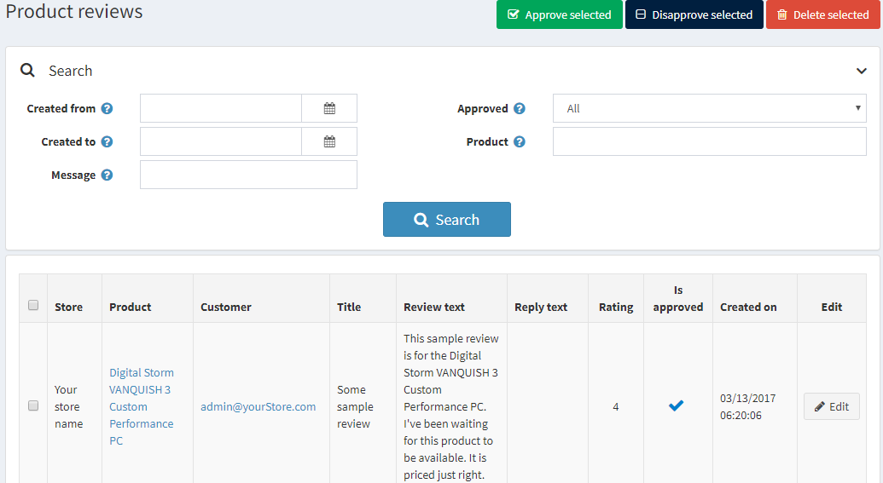

Search for reviews

You can search for reviews by:

* Date range using **Created from** and **Created to**. In the Created from and Created to fields, enter the date range for your search. Alternatively, you can click the dropdown calendar and select the required date range.
* **Message**. Can be used to find a review by title or text fragment.
* **Approved**. Can be used to find a review by the "Approved" property.
* **Product**. Sorts and shows the reviews related to a particular product.
* **Store**. Allows viewing all reviews of a particular store's products. This field is displayed if you have more than one store.

Approve or disapprove

Select the reviews you want to approve or disapprove and click the **Approve selected** button or the **Disapprove selected** button accordingly.

Editing product reviews

To edit a product review, click **Edit** beside the review. The *Edit product review details* window will be displayed as follows:

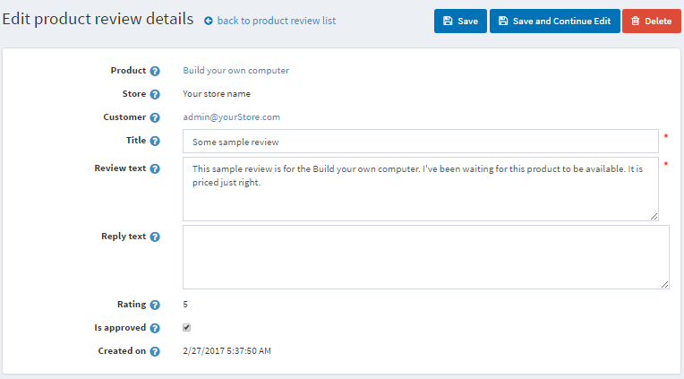

* See the **Product** for which this review was added. After clicking this field, you will be redirected to the edit product details window, where you can edit the product details.
* See the **Store** in which this review was written.
* And the **Customer** who created the review. After clicking this field, you will be redirected to the edit customer details window, where you can edit the details.
* You can edit the review **Title**.
* And its **Text**.
* In the **Reply text** field, you can leave a reply to review; it will be visible in the public store under the review.
* **Rating** displays the customer rating. It cannot be edited.
* Select the **Is approved** checkbox to approve the review.
* **Created on** shows the date and time when the review was created.

Review types

If you have created custom review types, you will see the *Review types* panel:

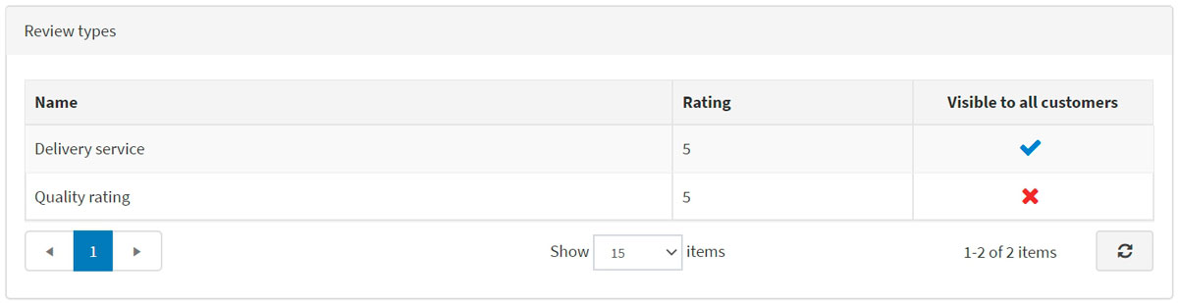

In this area, you can view all the additional reviews on the current product. **Rating** displays the customer rating. No columns in the table can be edited.